Acceptance Test:

Adjusted BLASTP parameters

Test Criteria:

After clicking the “BLASTP” or “BLASTN” button on the main screen the user is redirected to the respective tool GUI. Each Interface should have option for filtering the run based on three parameters (E-value, Maximum no. of Hits and Scoring Matrix).

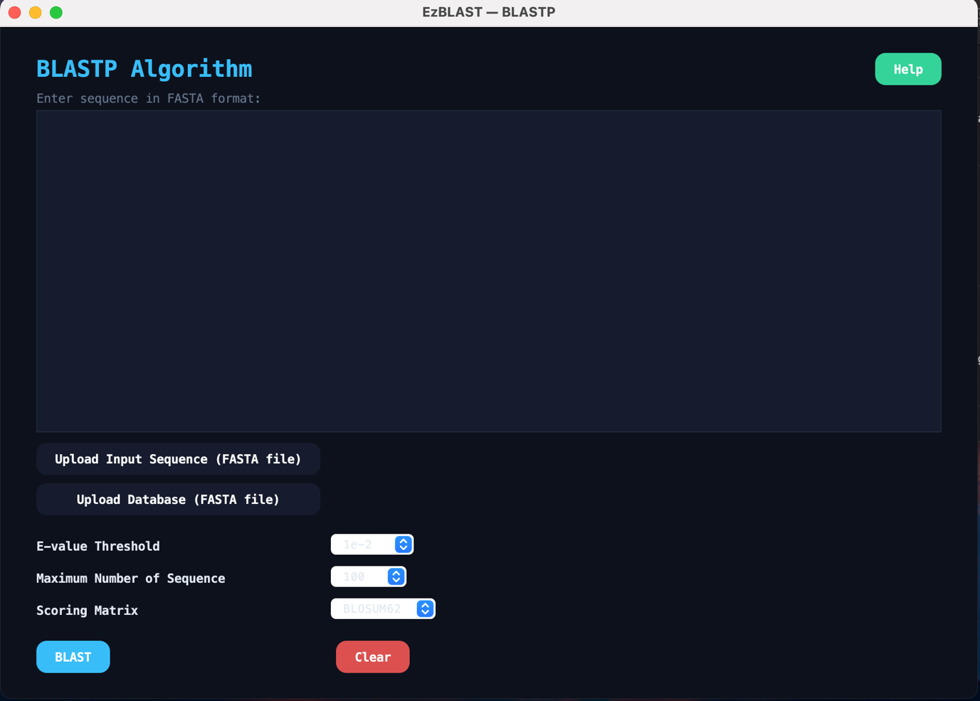

User can filter each parameter according to his need.

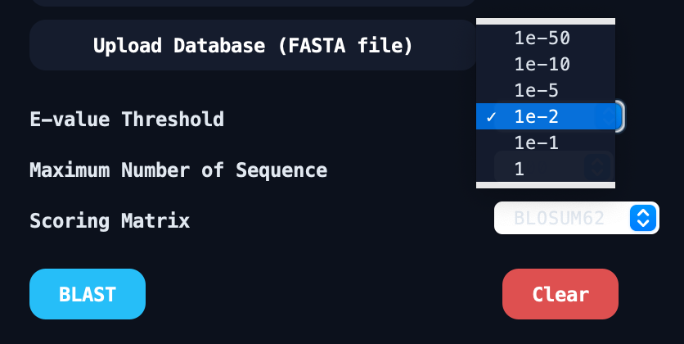

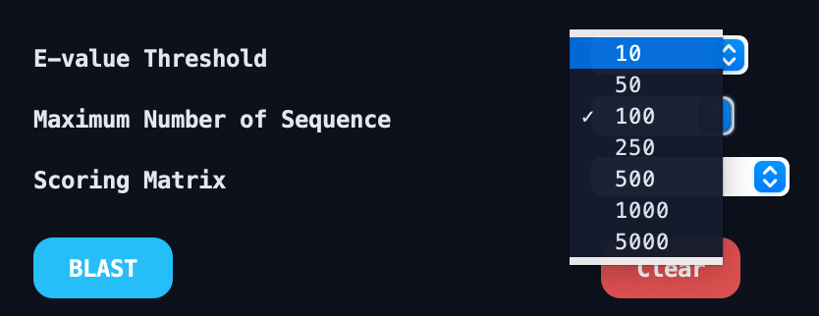

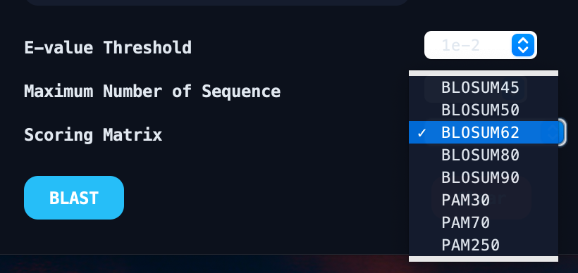

Based on the parameters user has selected the output should have maximum of 10 sequence out of which the highest E-value score should be “1e-2”.

This is the output screen and the best hit for the respective search and it’s ranked as 1 as visible in Select Blast Hit dropdown. It’s E-value is 3.7e-099.

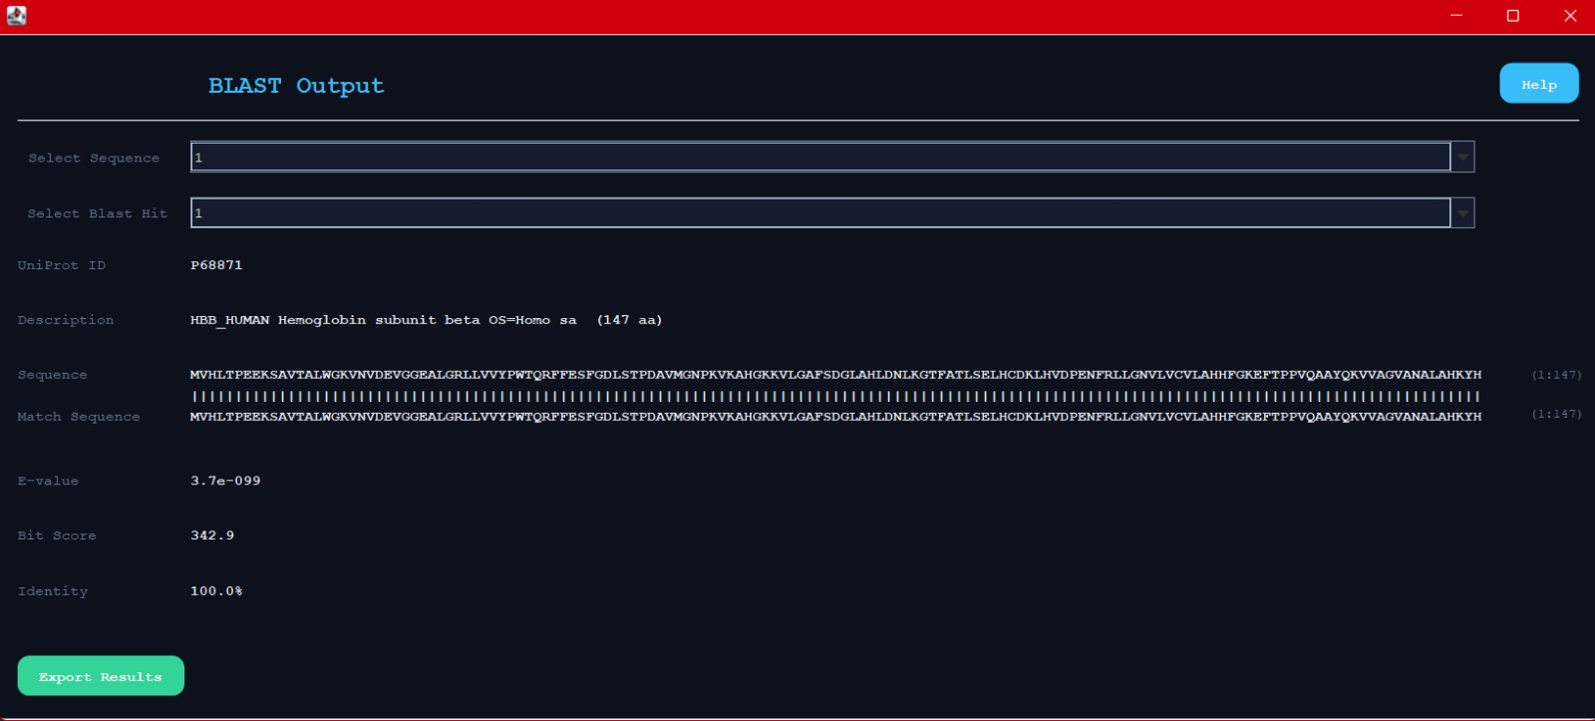

Maximum number of hits for the respective result was set at 10 and we got 3 hits which is less than 10. Hence the user can filter how many hits he wants to see.
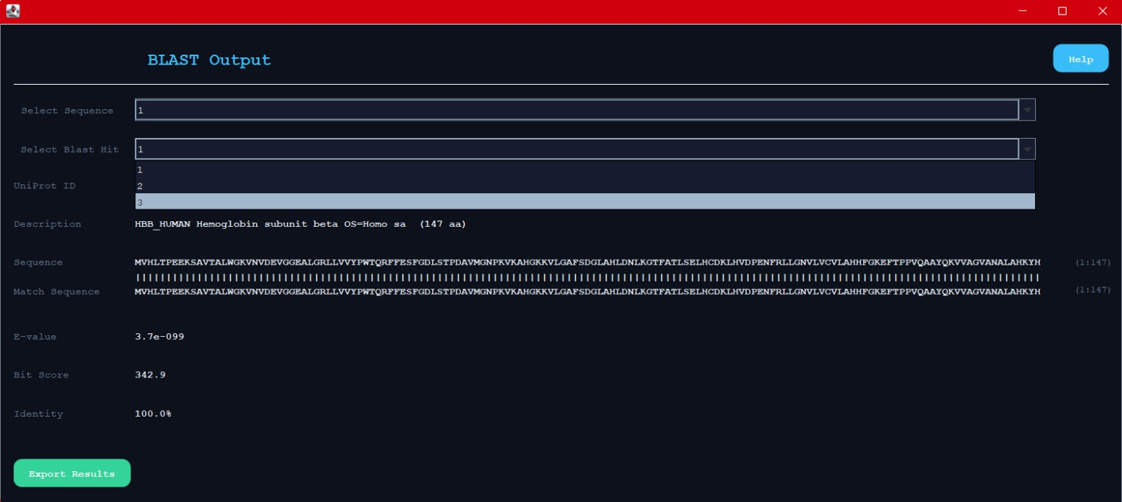

This is the last hit from the search which proves that the threshold for E-value is followed properly as the E-value for this hit was 3.5e-033. Hence the user can now filter the results according to his experimental needs.

